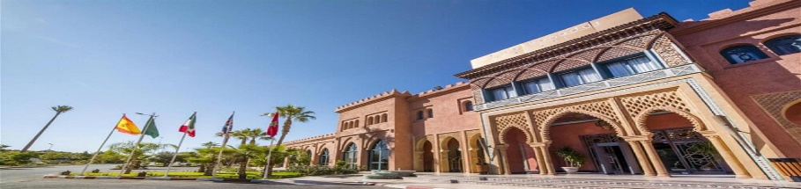
6th All Staff Workshop 2026 Marrakech, Morocco
Grand Mogador Agdal Hotel - Reservation Form

Guest Information

First Name
Last Name
Affiliation / Organization
Country
Email Address
Phone Number

Stay Details

Check-in date
Check-out date
Room Type | ☐ Single ☐ Double ☐ Twin
Special Requests (optional) | ☐ Late check-in ☐ Early check-in ☐ Late check-out

We kindly ask you to return the completed form by email to sahlaoui.zahra@marocmeteo.ma or hdidou.fatimazahra@marocmeteo.ma by 06 February at the latest.

